May 23, 2022

RIDEM
Office of Water Resources
235 Promenade Street
Providence, RI 02908

Subject: RIDEM Application No. 21-0300
Alteration to Wetland
COW Assessor’s Plat: 223; Lots 213, 215, & 216
Joseph Court

This letter is an objection and a recommendation for denial, in response to your Notice of Alteration to Wetland, Application No. 21-0300, dated April 28, 2022; for the property located along Joseph Court, Warwick, RI located within the Greenwich Bay Watershed, further identified as City Assessor’s Plat: 223; Assessor’s Lots 213, 215, & 216.

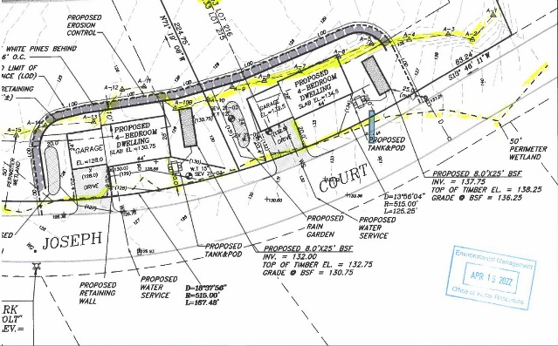
The Application notes an alteration of approximately 14,208 square feet of freshwater wetland. The proposed alteration is for a two-lot residential subdivision which will include but may not be limited to the construction of two new single-family residential dwellings, each with an attached garage, paved driveway, on-site wastewater treatment system (OWTS), water line, rain garden, retaining wall, evergreen plantings and landscaping.
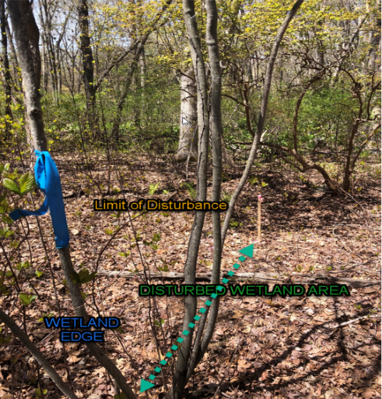
It is important to note that 100% of the proposed construction is within the wetland, which consists of a swamp and a 50’ perimeter wetland and the alteration will include at a minimum, filling, grading, vegetative clearing, excavation, and other related construction activity.

The application as proposed is NOT consistent with the City’s Comprehensive Plan, 2033; specifically, Chapter 4 Natural Resources, which details the following:

- Approximately one third of the total wetland area in Warwick is classified as freshwater wetlands. Wetlands, which include riverbank and perimeter areas, ponds, marshes, bogs, and swamps, are important areas for water retention and filtration, for plant and wildlife habitat, and help to protect life and property from flooding.

- In a mature suburban city such as Warwick, most of the native wildlife has disappeared or has dwindled to very low populations. There are, however, several areas in the City which support wildlife, primarily birds and aquatic life. The most important of these are the coastal and freshwater wetlands. All of Warwick’s wetland areas provide valuable wildlife habitat……………

- Protect freshwater bodies, coastal waters, areas with soil limitations, unique natural features, fish and wildlife habitat, and threatened and endangered species habitat through land use planning and regulatory management programs………….protect and restore Warwick’s coastal and freshwater wetlands and improve water quality.

The development encroaches into the forested wetland that is associated with the Dark Entry Brook and flows to the Maskerchugg River, which is listed on the State’s 303(d) list of Impaired Waters, protected by the Clean Water Act.

The Greenwich Bay Special Area Management Plan, notes the majority of the City’s Freshwater Wetlands as privately owned; which should be protected. This is further supported in the City’s Comprehensive Plan which also details the protection of existing wetland areas, through:

- Continue programs to implement the Greenwich Bay SAMP and all city TMDLs to improve the health of the bay. Identify and protect remaining wetlands, open space and shoreline areas within the Greenwich Bay watershed.

Additionally, the proposed application is NOT consistent with the Development Review Regulations-Design Standards and the City’s A-40 Residential Zoning District, specifically:

- The proposed grading sheds onto the City’s ROW (Joseph Court)

- The parcel requires at a minimum of a 40’ front-yard setback, this application is requesting a 50% deviation for the minimum standard.
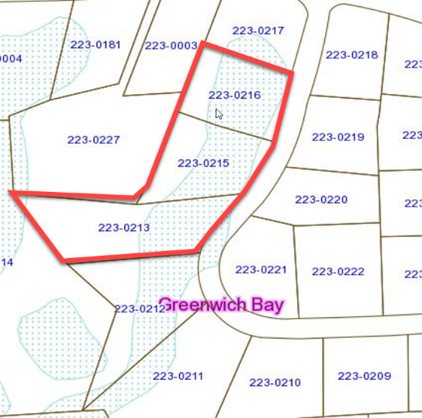
The City’s Conservation Commission reviewed the Application 21-0300 and forwarded a recommendation for denial, stating that the proposal is completely within the wetland area and approval would be a detrimental loss to freshwater wetlands which will affect flooding of adjacent areas, the related detrimental effect on wildlife including the elimination of wildlife habitat such as feeding, breeding, and nesting areas, as well as the elimination of the perimeter wetland which provides additional wildlife habitat and buffers the wetland habitat.

The City of Warwick Comprehensive Plan states that Warwick’s most important wildlife habitats are located in its wetlands; salt and freshwater marshes, streams, ponds, and the Bay.

Approval of this application is contrary to the City’s Comprehensive Plan, and would adversely impact water quality, valuable wildlife habitats and will promote further degradation of existing swamp and wetland areas and the Bay; taking the aforementioned into consideration the City strongly recommends that RIDEM deny the application.

Sincerely

Thomas Kravitz, Director
City of Warwick

